Banksy: Renegade Artist
Using striking stencil art and profound imagery, Banksy has captured the interest of art lovers, activists, and graffiti artists around the globe. His mysterious identity (and refusal to use social media accounts) has only sparked more intrigue, with media outlets and fans prying to earn a peek into his life. But why use graffiti as a means to communicate?
By displaying art in crowded cities across the world, Banksy puts social and political issues in our face. These pieces force us to stop and think—something that we often avoid doing in our day-to-day lives.

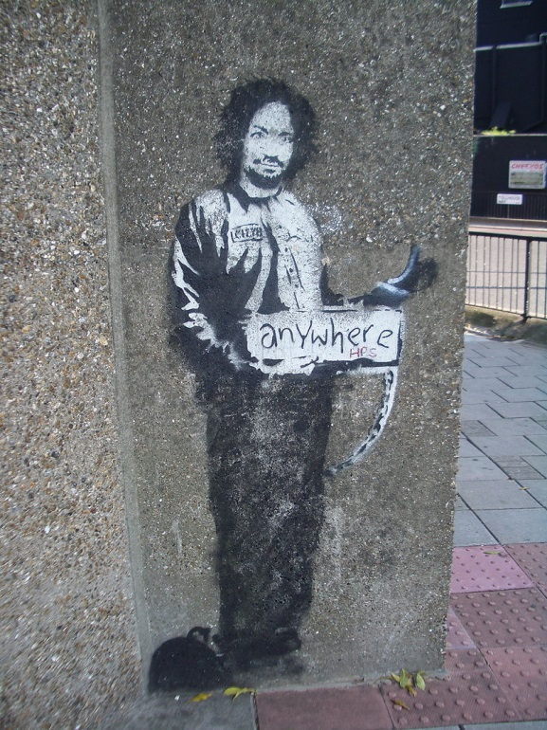
Set moral boundaries.
This ominous image of a hitchhiking Charles Manson stands outside of London’s Archway Tube Station. Could it be a reference to the pervasive influence of evil in society? An ominous warning that evil can be lurking on any corner? Perhaps we should be more restrictive of what kinds of influences we allow in our everyday lives.

Remember where you came from.
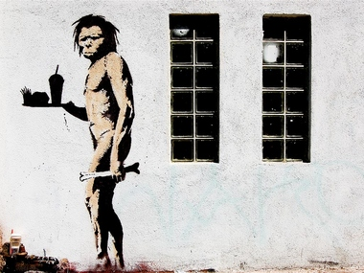Those who pass this piece in Los Angeles may wonder if they’re being warned, mocked, or simply entertained by a peculiar caveman with his fast food combo meal. Perhaps this is simply a subtle reminder of our human nature—and of those things that we’ve adopted that aren’t so natural. As crazy as it is to see a caveman carrying a fast food tray, is it really that much crazier for us to consume grease-soaked, nutritionless meals?

Let your actions match your words.
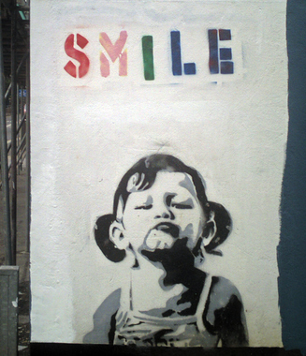
Have you ever been frustrated by a parent who said, “Do as I say, not as I do?” Maybe Banksy was too, before allegedly creating this piece in the London Borough of Hounslow. This piece brings to light the contradiction between what human behaviors are expected, and how people actually behave. We’re often told to be good by some of the very people that are doing just the opposite. Actions speak louder than words, so make sure your actions don’t contradict your words.

Everyone’s got skeletons.
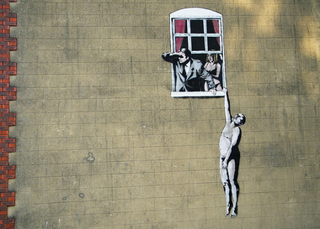This rather humorous scene is one of Banksy’s most famous, painted in Bristol, England. Along with the idea that we’ve all got some things to hide, this piece seems to warn us that things aren’t always what they seem. Don’t blindly believe everything you’re told, as someone’s dishonesty may be creating an illusion.

There is always hope.
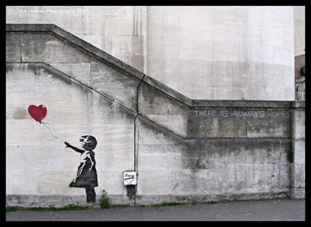This message is clearly etched in the wall beside this London piece. While the image may symbolize loss, the text clearly tells us that no amount of loss can eliminate hope. This is a gentle reminder to remain positive instead of wallowing in our losses.

Strive for peace.
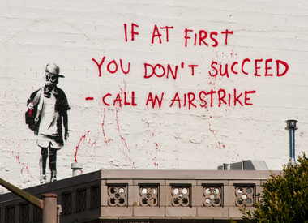This San Francisco piece demands that we examine ourselves—particularly, how we solve problems. Instead of resorting to violence and immature tantrums, we should aim to be reasonable and fair. This is one of many Banksy pieces that pushes us to question our government and the decisions made by our leaders.

Love is not lust.
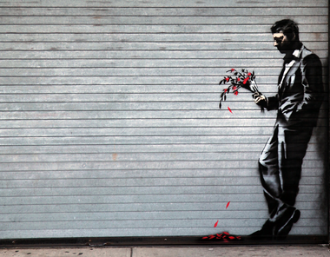This dismal scene, painted outside of a New York City strip club seems to highlight the ugly truth about society’s sex obsession: it never leads to fulfillment—at least not for this poor guy. Banksy posted the phrase, “waiting in vain” along with a picture of the stencil on his website, suggesting he’s in the wrong place if he wants to find genuine love.

All love is valid.
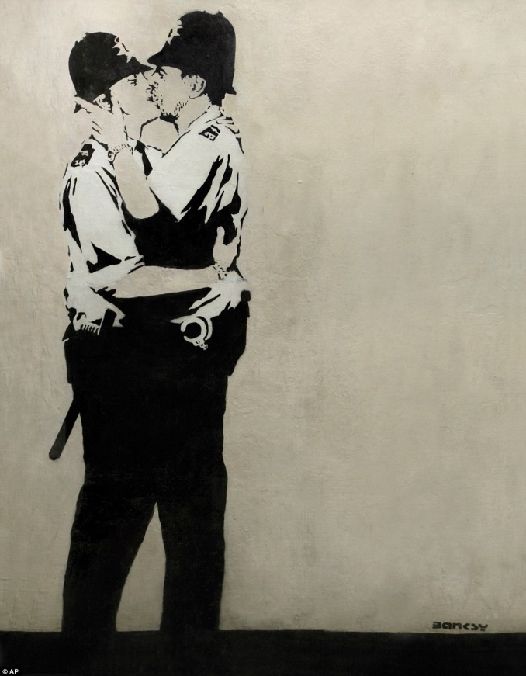This piece, outside of a Brighton pub, blatantly displays two uniformed male officers kissing. Banksy seems to be asking us, “Who’s to say what is appropriate?” Whether “conventional” or not, love is love. This piece suggests that love should be accepted publicly and displayed freely, no matter what kind it is.

Be humble.
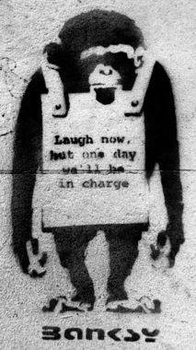
Let’s face it: most humans need a lesson in humility. We’ve caused tragedies for other species, the environment, and other humans without even recognizing any wrong-doing. Banksy reportedly painted several of these pieces, reminiscent of the popular anecdote: don’t step on the little people to get to the top, as you may need them on your way back down. More importantly, don’t step on people because it’s wrong. Practice humility, and you will naturally earn respect without having to mistreat anyone.

Utilize kindness.
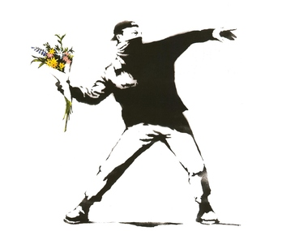This London piece of a protester throwing a bouquet of flowers may be Banksy’s most famous piece thus far. The remarkable idea behind this piece is the use of unexpected weapons. The protester fights not with a grenade or other harmful device, but with an innocent bouquet of flowers. This suggests we may be able to get more done by negotiating kindly, not malevolently.

Express yourself.
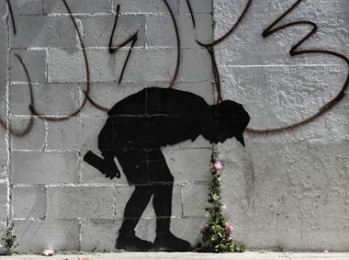This New York piece illustrates self-expression with a graffiti artist puking flowers. The caption tied to this piece is “better out than in,” indicating that if you have something to express, it’s best to let it out rather than hold it in. We certainly wouldn’t hold it in if we felt the need to puke. So why hold in our emotional needs, like the need to express and create? Whether physical or emotional, some things need to be let out, lest we be left with a sour stomach.

Live in the moment.
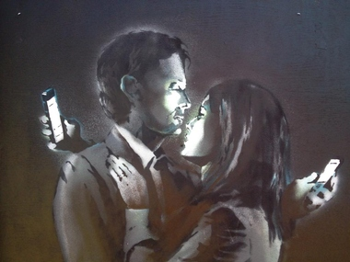One of Banksy’s most recent pieces, entitled Mobile Lovers, was also done in Bristol. This not-so-subtle reference to modern technology warns us to be conscious of what we’re spending our time and attention on. Nothing that exists on a screen in more important than what is happening right in front of us. By being constantly preoccupied, we could miss out on meaningful opportunities and connection with others.

Don’t be so full of yourself.
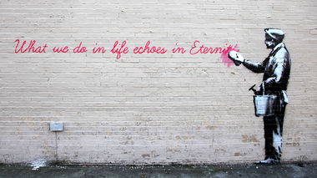
Another New York piece of Banksy’s casually knocks us down to reality. As humans, we like to believe that our lives have significance and that we’re unique from everyone else. This piece can be viewed as something that knocks us down a peg, but in a good way. Everyone lives the same struggle. Life is finite, and that’s okay. Don’t do things in order to be remembered; do things in order to be a good person.

Listen to your heart.

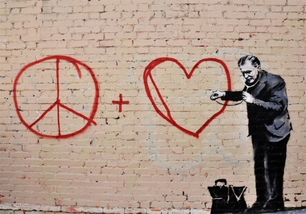
Perhaps the most obvious and adorably heartwarming translation of this San Francisco piece is “listen to your heart.” While harsh realities and unforgiving satire are typically Banksy’s style, a bit of optimism seeps through here. This listening doctor serves as an inspiring reminder. Are we living up to the request?

Don’t let others deter you.
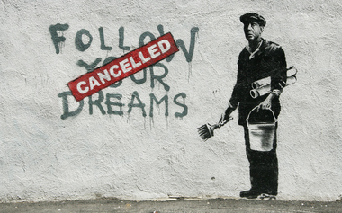
This Boston piece, one of Banksy’s most famous, takes yet another swing in the name of disappointed idealism. Many of us feel forced to give up our dreams, never pursuing them due to financial burdens or other hardships. This may serve as a wake up call for those of us who’ve been asleep. Ultimately, we should follow our dreams, regardless of outside discouragement.

