Satire Assignment (100 Points)
Learning Goal – to demonstrate your understanding of satire and key techniques in creating satire.
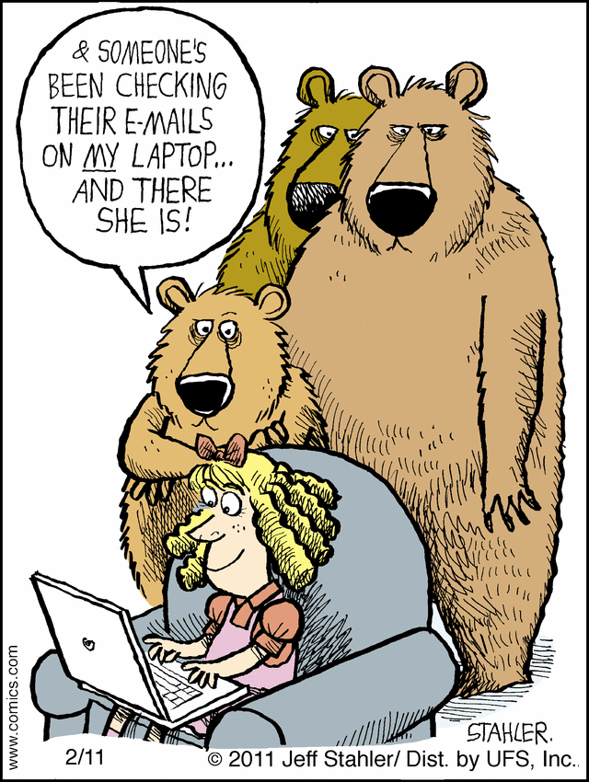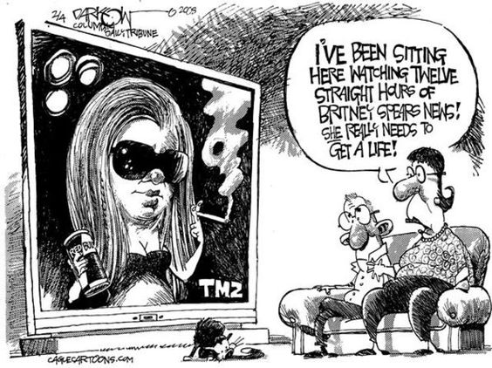
I. For your final assessment, your job is to write an original satiric piece. You have two options: You can either write an essay (similar to your Civic Position Statement) or a news article (similar to what you have read in The Onion). Regardless of which option you choose, your final product should be multiple paragraphs. Your response should be no more than two pages. Here are some things for you to consider in creating your satiric piece:
- Identify a social problem/issue; the issue can be something small or something on a larger scale. You will write a satirical essay in which you provide potential “solution(s)” to the issue(s). Your topic and problem must be specific and clearly defined, as well as your solutions, both satirical and real. Consider “A Modest Proposal” as an example of a problem + satirical solution.
- Essay should follow typical essay structure:
  - 1. State Problem
  - 2. Define problem with support
  - 3. Offer satirical solution
  - 4. Describe and define satirical solution and its effectiveness with support
  - 5. Explain why there cannot be objections
  - 6. List and dismiss real solutions
  - 7. Conclusion
- You must suggest and defend both a satirical solution, which will be the bulk of your paper.
- Think of a situation, behavior, person, anything, in school, society, politics, entertainment – any topic, anywhere that you feel deserves to be satirized – and satirize it. Write a newspaper article, similar to The Onion in which you satirize the subject.

II. Whichever format you choose, on a separate sheet, compose a commentary on or explanation of your piece that answers the following questions:
- Who, or what, is the target of your satire, and why?
- What are the main techniques used in your satire, i.e. Exaggeration, Incongruity, Reversal, Parody, Irony (Situational, Dramatic, Verbal)
- How successful do you think your satire is in achieving its aim?

When writing satire, please consider the 3 M’s:
- Misunderstanding: Audience may think the satirist is being serious.
- Misuse: People hide behind the idea of satire to get away with saying really stupid and cruel things.
- Missing the Point: Too much satire can distract the audience from the “real” message.

